ANNUAL REPORT OF B.Voc HEALTHCARE MANAGEMENT FOR 2018-2019
There was much excitement and enthusiasm amongst students of B.Voc. as our first batch had entered third year which would be passing out in May 2019.Our department has been working very hard to arrange internships to give students hands-on-training and bring different Hospitals/Pharmaceutical companies & Health Centers on campus for the Recruitment of Final year students. We also bring in various professionals from the Corporate Sector to address B.Voc students in the form of Workshops, Seminars and Interactive Discussions.
The Nodal Officer of B.Voc department worked diligently to bring in a partnership with the Reach Out team of Sir Ganga Ram Hospital (SGRH) to start an Out Reach Program for B.Voc students in ‘Geriatrics’ and ‘Adolescents’.

Out Reach Program in Geriatrics:
This initiative aims at providing physical & emotional support to geriatrics in need of help. This will inculcate a sense of social responsibility, develop and nurture the right values of compassion and service in our students.

- A group of our students went to an Eye Camp held at Geeta Bhawan in Kirti Nagar organized by the ‘Reach Out’ team of SGRH on 1st and 2nd February ’19.The students documented the Patient’s Details & made them feel comfortable.

- Some students from Geriatrics Group went to `Nirmal Chhaya’,old- age home in Chhatarpur on 19th February & 19th March ‘19 where they had an amazing interaction and learnt about the experiences and challenges faced by the elderly.

- 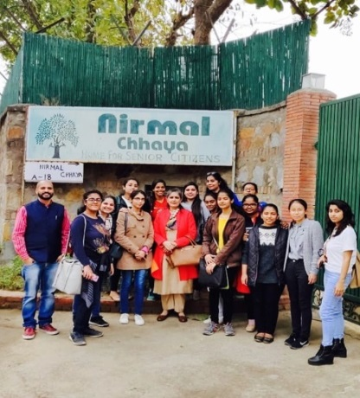

Outreach Programme in Adolescents:

The aim of this initiative is to enable our students to visit schools/institutions to counsel and guide the adolescents to help them deal with the specific challenges of this age group.
To achieve this objective, students have been trained by the team of doctors from SGRH to become certified counselors.

- The Students assigned to the Adolescent group went to GD Salwan Public School, Rajinder Nagar on 30th March ‘19 where they conducted an Orientation session for the parents on different topics such as Healthy Tiffin and Snack options for kids, overall development of children, challenges faced by working parents & Comparison between siblings.

- The students also went to P.G.D.A.V School, Patel Nagar on 8th April ‘19 wherein they conducted a session for the students of class 7 & above. They spoke on different topics such as Disadvantages of excess use of Internet, Importance of doing well in academics, Fallout of using foul language and Good behaviour-a key to success.

Seminars/Talks/Workshops:
- An Interactive Session was held on “BREAK THE GLASS CEILING” by renowned speaker MS. DEEPTI PATHAK on 6th SEPTEMBER ‘18 where she talked about ‘how to Cultivate your mind’, ‘Master your emotions’, ‘Be Fearless and Never give up’, ‘Rising to position of power’.

- A talk on “Overview of Hospital” was conducted by Dr.Sanjay Sharma, Group President of Park Group of Hospitals on 26th October ‘18 where students got glimpses of facts and challenges about Hospital industry and how to succeed in the face of these challenges.

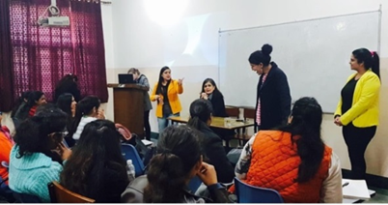

3. An Awareness Seminar on the ‘Geriatrics and Adolescents’ was conducted in collaboration with Sir Ganga Ram Hospital on 21st January ‘19 at SGRH. It was an interactive session by the Health Experts from the hospital in which the problems and challenges related to old age & adolescents were discussed.

4. An Interactive Session on internet addiction and Obesity in Children & Adolescents was held by Dr. Kavita , Dr. Latika Bhalla and Ms. Sharan Sethi from the ‘Reach Out’ team of SGRH at JMC on 31st January ’19.
5. A seminar was arranged in collaboration with IIHMR University; a leading name in Healthcare Teaching, Research and Training on ‘Different Career Prospects For Non-Medicos in Healthcare Sector’. It was conducted by Dr. Sandeep Narula, Associate Professor and Academic Dean of IIHMR on 21ST February ‘19. The students learnt about Hospital Administration, role of Business Analyst, Healthcare Managers, and Operation Managers etc.

- Workshop on Basic Life Support in collaboration with Primus Super Speciality Hospital, New Delhi was conducted on 11th March ‘19 in the College Auditorium by Dr. Abhitab Sagar, Senior Consultant-CTVS and Anaectesia, Primus Super Speciality Hospital. Importance of- GOLDEN HOUR and the Art of Saving Life was taught along with BASIC LIFE SUPPORT techniques like CPR. A demonstration was also given to the students tried with the dummy.

- An interactive session on “NABH the core of Quality in Hospitals” was conducted on 23rd April, 2019 by Dr. Ashok Kumar, Medical Director-Primus Super Speciality Hospital, New Delhi.

Co-Curricular activities :
Annual Sports Day: students turned out smartly for the March Past and also bagged 2ND Position in Caterpillar Race and 3rd Position in Tunnel Race.

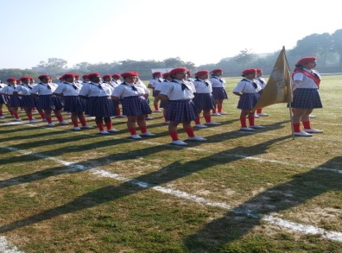

Placements
Park hospital- Gurgaon -7 students have got an offer
C K Birla hospital—1 student
We also got an opportunity from different hospitals for Recruiting our final year students but the offers were turned down due to certain constraints and we have invited the Organisations/Hospitals to come for Recruitment drive in the month of May 2019 after the exams.

